Lab Week 3

# Robert Gabriel

# Web Development Year 2

# R00102430

# Purpose: To gain an understanding of the following:

* System Sequence Diagrams
* Events
* Domain Models
* Operation Contracts

# Q1. Prepare a system sequence diagram for use case *“`professor submits grades”*

(Specification created in Lab 2)

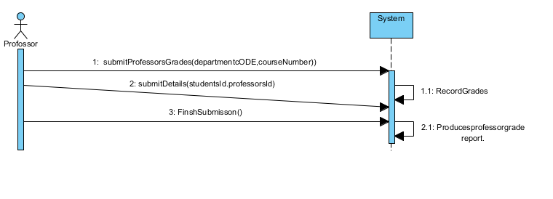

# Q2. Consider an Event table for a library system.

# Make appropriate assumptions to limit the scope of the system. Focus on events related to the circulation of books. Ignore the acquisition and disposal of lendable items.

|  |  |  |  |  |  |
| --- | --- | --- | --- | --- | --- |
| Event Number | Event Description | System Input | Actor Providing Input | System Out Put | Actor Receiving |
| 1 | Patron takes a book out | Card and Book Details | Patron, Staff | , Return date and patron information | Patron |
| 2 | Paton returns a book. | Book and Id Card | Patron, Staff | Thank you | Staff |
| 3 | Paton Pays Fine | Money , Id | Patron, Staff | Receipt | Patron |
| 4 | Patron receives a Book | Book Id and Id Card | Patron, Staff | Booking Id,  Patrons ID | Patron |

# Q3.

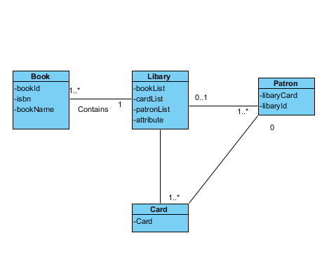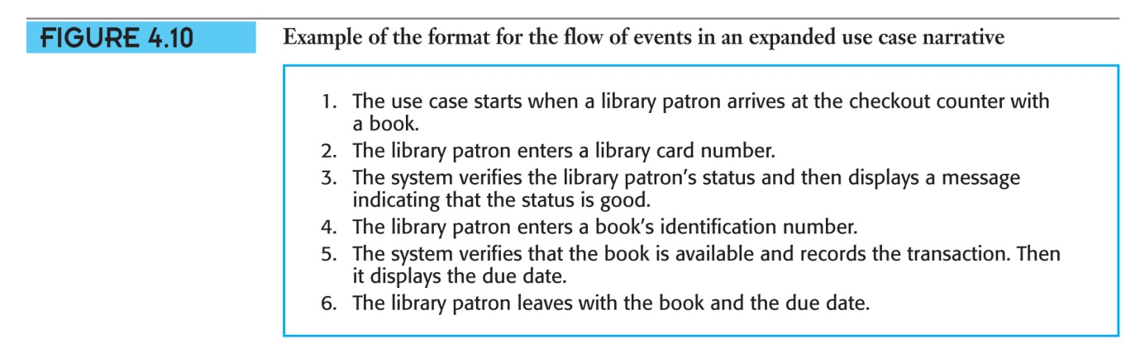

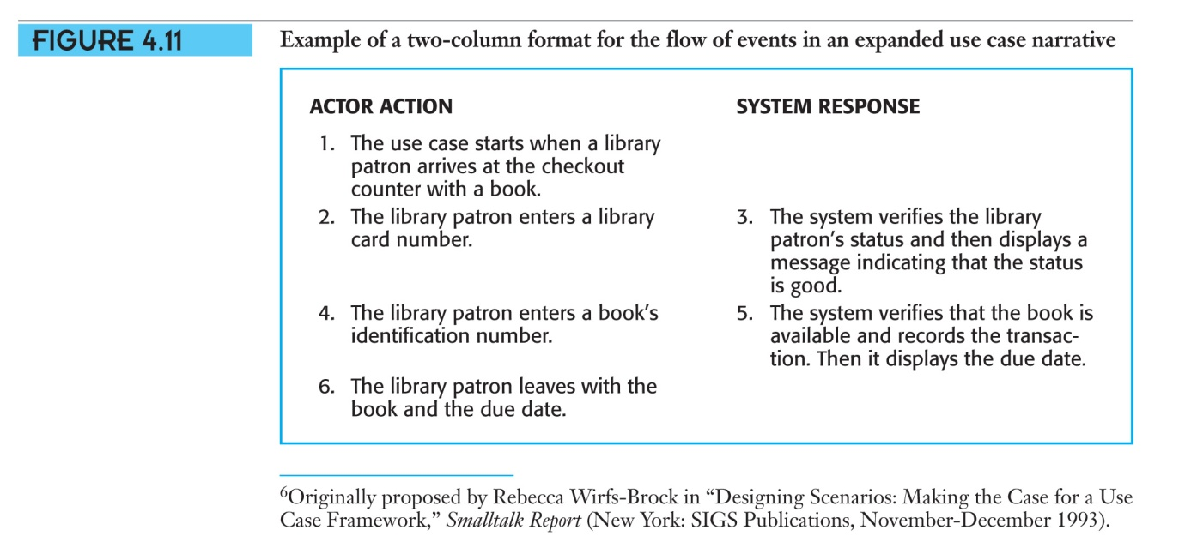

# Q4 Modify the domain model Figure 5.23. for the Public University Registration System to accommodate the new events identified in lab 2

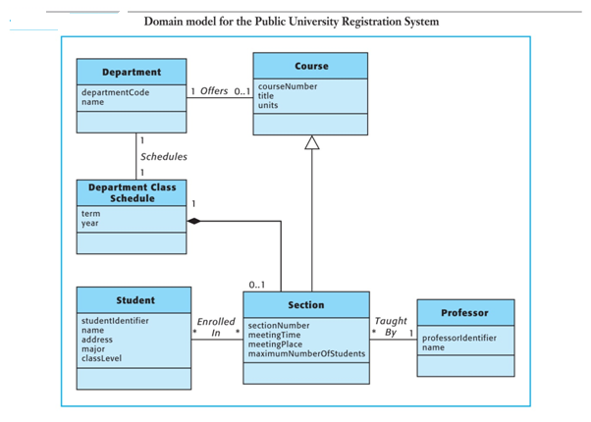

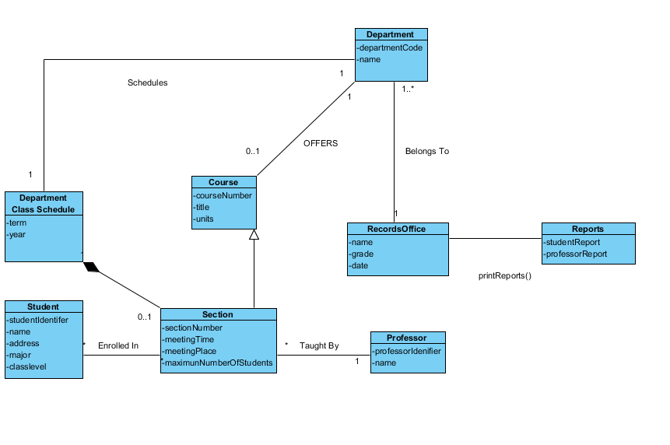

# Q5 Write a system operation contract for each of the operations shown in your system sequence diagram below



Contact

Name: enterCardNumber(cardNumber)

Responsibilities: Accept and validate the library card Number for that person.

Type: System

Exceptions: if the library card is not valid , indicate that it was an error.

Card and Patron is known to the system.

Preconditions: Patron is known to the system.

Library card is known to the system

Postconditions : None.

Output :

Contact

Name: enterBookIdentifier(bookIdentifier)

Responsibilities: Accept and validate the book and book Identifier are own to system.

Type: System

Exceptions: if the book and book Identifier is not valid, indicate that it was an error.

Book and book Identifier is known to the system.

Preconditions: book and book Identifier is known to the system.

Book and book Identifier is known to the system

Post conditions: None

Output : Display receipt to Patron.